**Virtualization and containers**

**DOCKER INASTALLATION…..**

**SUBMITTED BY:**

VIJAY VISHNU PB

ROLNO:49

S2 RMCA B

**SUBMITTED TO:**

SRUTHIMOL KURIYAN

**Aim**

Install the docker.

**Procedure and Output**

1.Open the terminal on Ubuntu.

2. Remove any Docker files that are running in the system, using the following command:

**$ sudo apt-get remove docker docker-engine docker.io**

After entering the above command, you will need to enter the password of the root and press enter.  
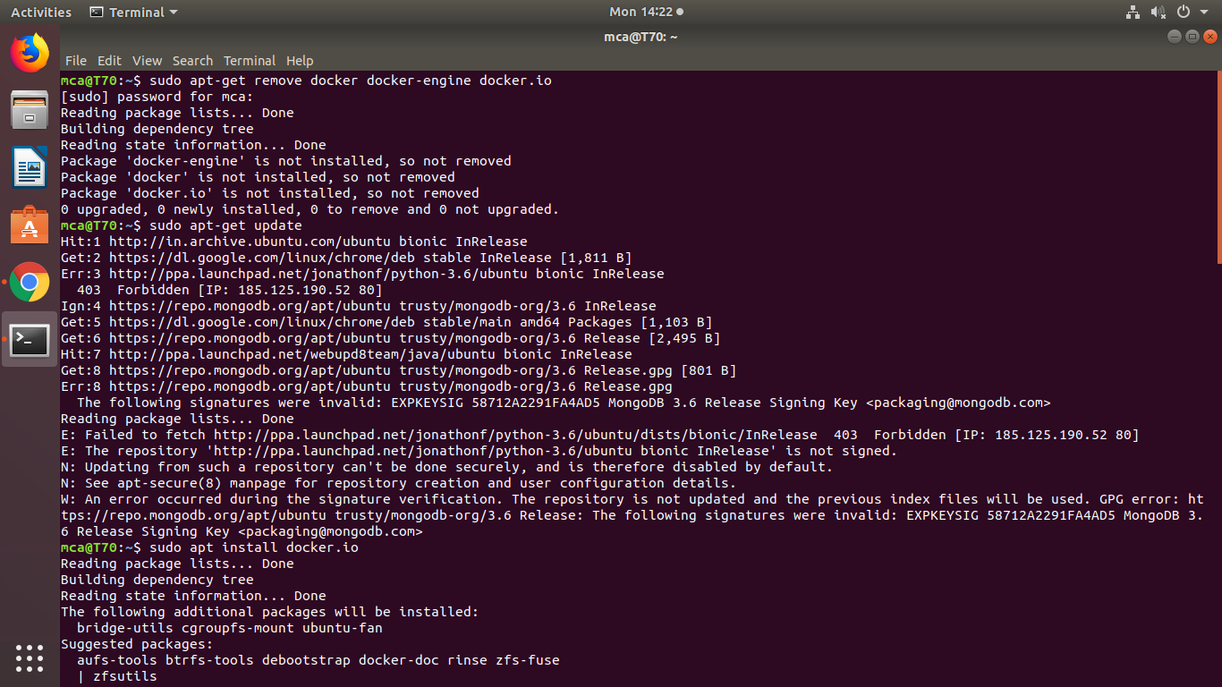

3. Check if the system is up-to-date using the following command:

**$ sudo apt-get update**



4. Install Docker using the following command:

**$ sudo apt install docker.io**

choose yes or no



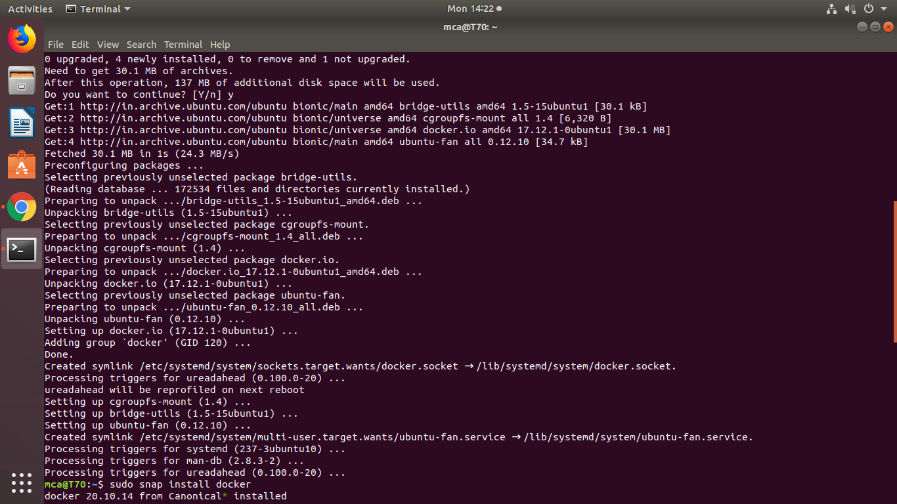

5. Install all the dependency packages using the following command:

**$ sudo snap install docker**

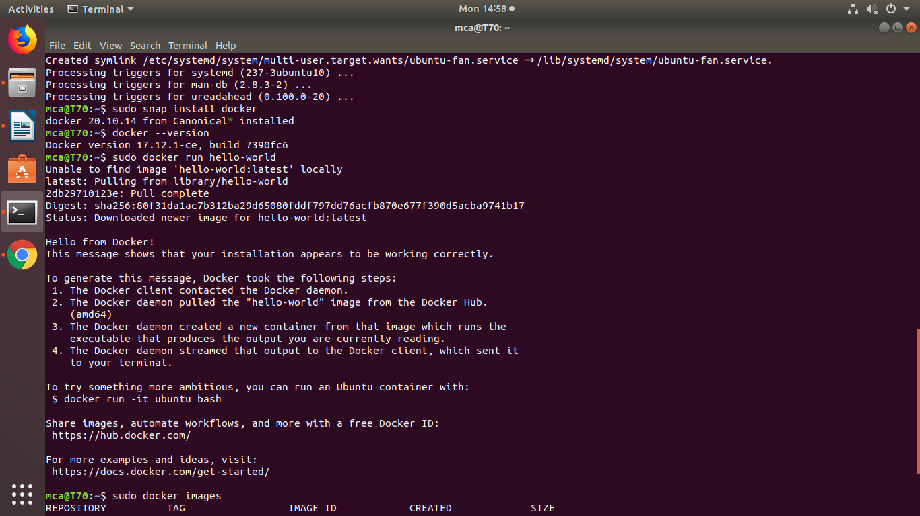

6. Before testing Docker, check the version installed using the following command:

**$ docker –version**



7. Pull an image from the Docker hub using the following command:

**$ sudo docker run hello-world**

Here *hello-world* is the docker image present on the Docker hub.

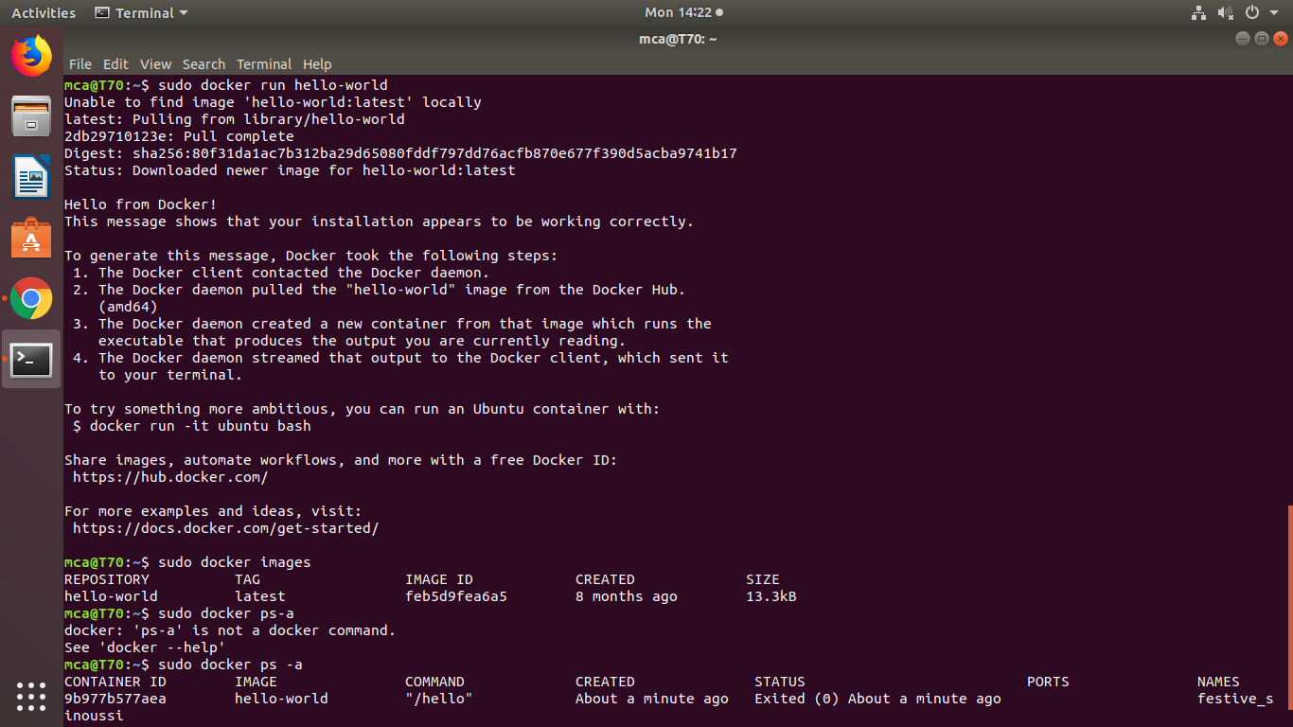

8. Check if the docker image has been pulled and is present in your system using the following command:

**$ sudo docker images**



9. To display all the containers pulled, use the following command:

**$ sudo docker ps -a**

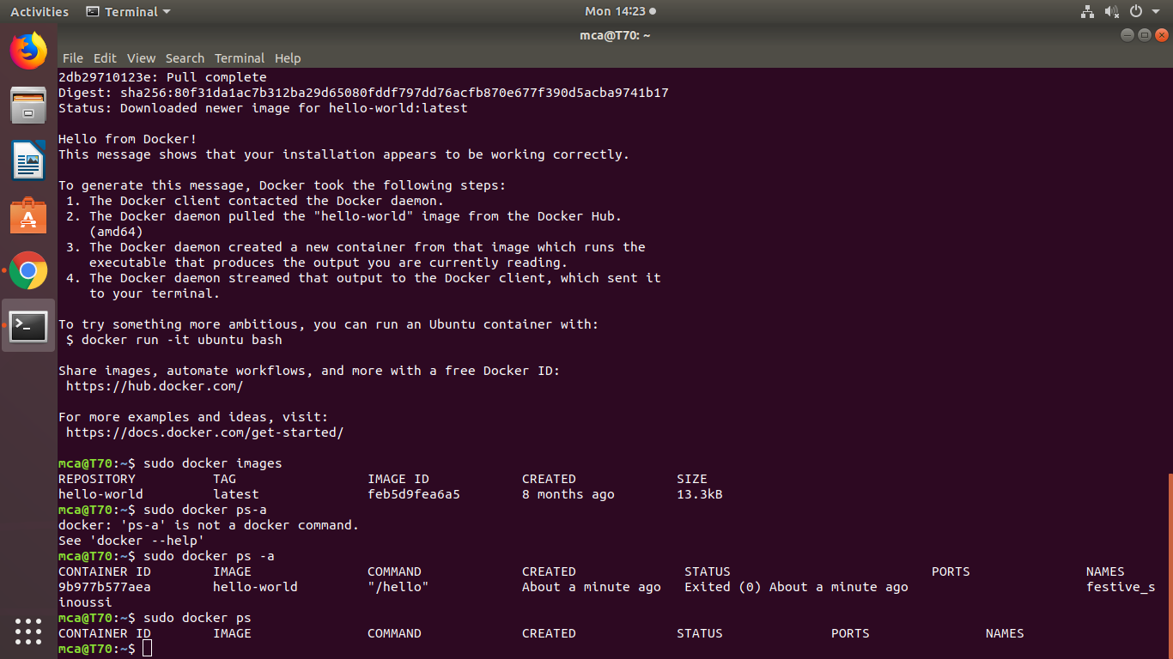

10. To check for containers in a running state, use the following command:

**$ sudo docker ps**



11. serve a simple web page from **/home/user/website**.

**sudo docker run -dit --name tecmint-web -p 8080:80 -v /home/user/website/:/usr/local/apache2/htdocs/ httpd:2.4**

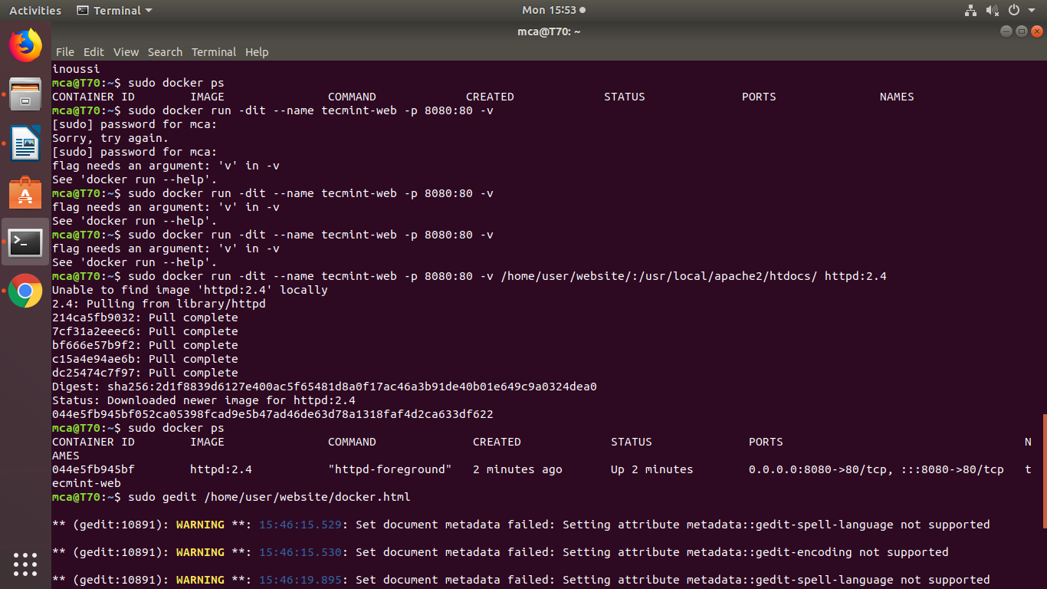

12.  list the running containers by default

**$ sudo docker ps**



13.Now let’s create a simple web page named **docker.html** inside the **/home/user/website** directory.

**$ sudo gedit /home/user/website/docker.html**

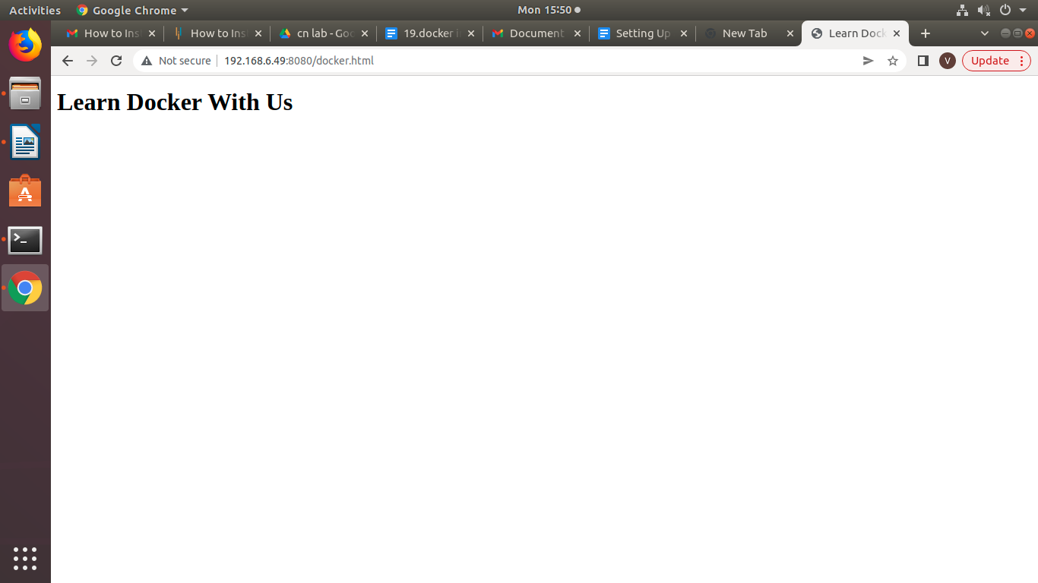

14. If you wish, you can now stop the container.

**$ sudo docker stop tecmint-web**

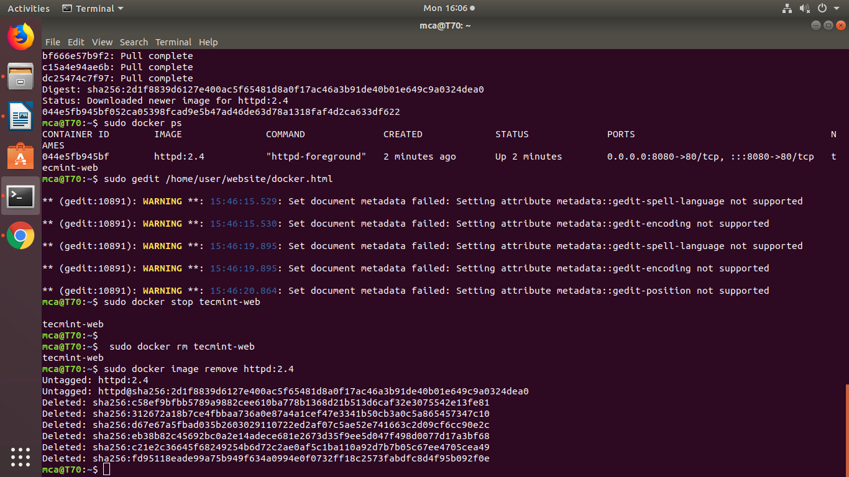

15.remove the container

**$ sudo docker rm tecmint-web**



16.delete the image used in container

**$ sudo docker image remove httpd:2.4**

